**ORXe-Time Picker**

### Document Properties

| Item | Details |
| --- | --- |
| Document | Technical Specification Document |
| Application | Orxe-time picker (version: 0.0.1) |
| Author | Pooja Paigude |
| Creation Date | 23/9/2020 |
| Last Updated | 24/9/2020 |
| Status | Completed |

Contents

Document Properties 1

1. Component Overview 3

1.1 Objective 3

1.2 Diagram 3

1.3 Use Cases 3

1.4 Risks 4

1.5 Out of Scope 4

2. Technical Specifications 4

2.1 NPM details 6

2.2 NPM repo 6

3.Unit Testing 6

4. Assumptions 7

5. Concerns and Issues 7

1. Component Overview

This document provides an overview of the counter component. The component can be used to select a time from time range.

1.1 Objective

The time picker used to select the time range from given time intervals

It consists of:

* **Selection Dropdown** – It is responsible for selection of time intervals

1.2 Diagram

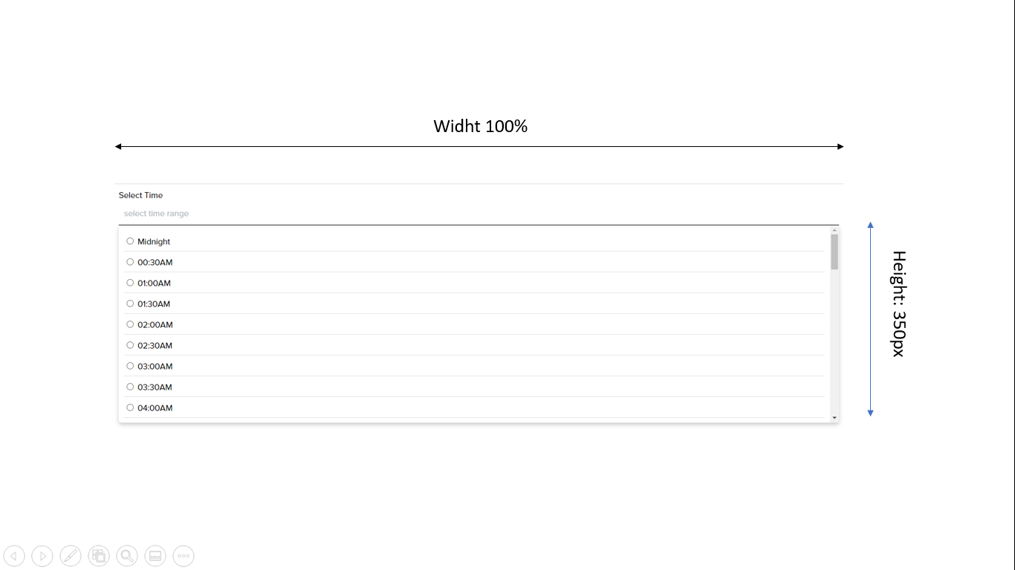

1.3 Use Cases

This document focuses on following use cases of the time picker component:

* **Select Input**: On click of input, it will open a dropdown with interval of time to select a time range



1.4 Risks

NA

1.5 Out of Scope

Defined certain styles for alignment and positioning for creating the base component.

2. Technical Specifications

The time picker component can take in up to following properties:

* **timeIntervalInMinutes:** This property is used to pass the interval of time we want to display while selecting time range.

<orxe-time-picker timeIntervalInMinutes="30"></orxe-time-picker>

* **selectedTimeRange** – This propert will output the selected time rage. It has implemented with CustomEvent and has printed in console of index.html file.
* **inputTitle** – This property specifies if the user wants to set the input field title.

  <orxe-time-picker inputTitle="Select time range"></orxe-time-picker>

* **closed** – The input property is used if user wants to keep dropdown open by default.
* **placeholder** – This property specifies if user wants to display the placeholder and its value can be passed using text object.

The component has below technical properties:

|  |  |
| --- | --- |
| **Property** | **Value** |
| Card Corner Radius | 8 px |
| Selection Color | [$secondary](https://tavisca.atlassian.net/wiki/spaces/ORXE3/pages/773392576/Colors+0.3) |
| Font Family | [$primary-font-family](https://tavisca.atlassian.net/wiki/spaces/ORXE3/pages/780403405/Typography+0.3) |
| Font Size | --cmp-txt--sb-fs |
| Font Color | [$secondary-text](https://tavisca.atlassian.net/wiki/spaces/ORXE3/pages/773392576/Colors+0.3) |
| Selected Font Color | [$secondary](https://tavisca.atlassian.net/wiki/spaces/ORXE3/pages/773392576/Colors+0.3) |
| Font Weight | Regular |

2.1 NPM details

Following packages are installed for project:

Orxe/cli version – v2.0.20

Following command creating and running the component:

* **Installing** orxe/cli - npm install -g @orxe3/cli
* **Create a new component workspace** - orxe new component-workspace orxe-assignment
* **Create a component** – orxe g c time-picker
* **Serving the component** – orxe serve
* **Testing the component** – orxe test –coverage

Following are the steps to **use the orxe-** **time-picker component in another component**

* Go to the component workspace and perform **npm install @orxe-assignment/time-picker@0.0.1**
* **Use the compone**nt as mentioned in the above section
* Run: **orxe serve**

2.2 NPM repo

The component is published at: https://packages.common.cnxloyalty.com/service/rest/repository/browse/npm-stage-hosted/

3.Unit Testing

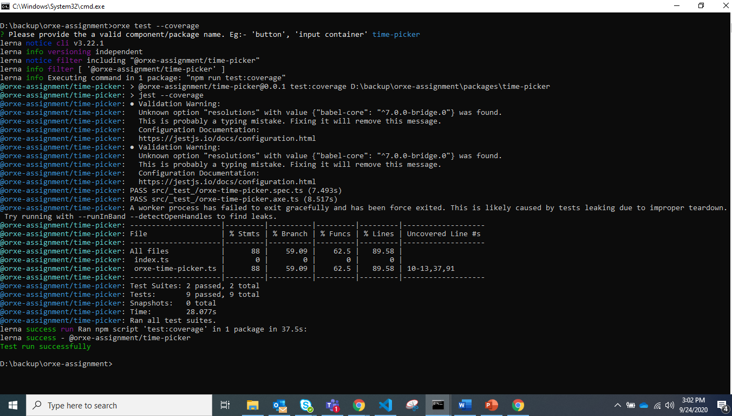

4. Assumptions

This component is developed based on the design guidelines provided on the confluence page.

https://tavisca.atlassian.net/wiki/spaces/ORXE3/pages/780272512/Time+Picker+0.3